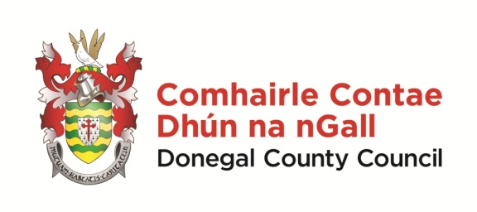 | Scéim Scoláireachta 2023  Gaeltacht Scholarship Scheme 2023  Foirm Iarratais/Application Form

NÓTA: Please take the time to complete this application form clearly and legibly.
Details of successful candidates will be forwarded to the relevant colleges.

Applicant Details:

Ainm/Name: _____________________ Sloinne/Surname: _____________________________

Seoladh/Address: __________________________________________________________________
__________________________________________________________________________________

Dáta Breithe/DOB: ______________ Uimhir Theileafóin/Phone no: ______________________

Ríomhphost /Email: ________________________________________________________________

Deimhnigh/confirm email: ___________________________________________________________

Name of school you currently attend:

An bhfuair tú scoláireacht ón Chomhairle seo roimhe? Yes _____ No ______
Have you previously received a scholarship from this Council?

Which Gaeltacht College would you like to attend?

If we are unable to offer you a place on the college of your choice, would you like to be considered for other colleges? If you tick ‘no’, no alternative offers will be made.

Yes ___ No ___

Do you consent to a photo of your child being taken for the purposes of promoting the scheme?

Yes _____ No ________

Síniú an Tuismitheora/Chaomhnóra/
Parent or Guardian Signature:

Name of Parent or Guardian in BLOCK CAPITALS: _________________________________________

Dáta/Date

Seol d’iarratas chuig/please forward application to –

sceimscol@donegalcoco.ie

nó chuig - Róise Ní Laifeartaigh, Oifigeach Gaeilge Pobail, Rannóg na Gaeilge,
Comhairle Contae Dhún na nGall, Ionad Seirbhisí Poiblí, Leitir Ceanainn, Contae Dhún na nGall.

Application Forms to be received on or before -Thursday, 23 Feabhra 2023

Cuirfear fios ar na buaiteoirí/successful applicants will be notified/i mí an Mhárta/in March 2023

